**Exercise 1: Control Structures**

**Scenario 1:** The bank wants to apply a discount to loan interest rates for customers above 60 years old.

* + **Question:** Write a PL/SQL block that loops through all customers, checks their age, and if they are above 60, apply a 1% discount to their current loan interest rates.

**Scenario 2:** A customer can be promoted to VIP status based on their balance.

* + **Question:** Write a PL/SQL block that iterates through all customers and sets a flag IsVIP to TRUE for those with a balance over $10,000.

**Scenario 3:** The bank wants to send reminders to customers whose loans are due within the next 30 days.

* **Question:** Write a PL/SQL block that fetches all loans due in the next 30 days and prints a reminder message for each customer.

**CREATION OF TABLES**

CREATE TABLE customers (

customer_id NUMBER PRIMARY KEY,

name VARCHAR2(50),

age NUMBER,

balance NUMBER(10, 2),

is_vip CHAR(1) DEFAULT 'N'

);

CREATE TABLE loans (

loan_id NUMBER PRIMARY KEY,

customer_id NUMBER REFERENCES customers(customer_id),

interest_rate NUMBER(5, 2),

due_date DATE

);

**INSERTION OF VALUES**

INSERT INTO customers VALUES (1, 'Alice', 65, 15000.00, 'N');

INSERT INTO customers VALUES (2, 'Bob', 45, 9500.00, 'N');

INSERT INTO customers VALUES (3, 'Charlie', 70, 5000.00, 'N');

INSERT INTO customers VALUES (4, 'Diana', 30, 12000.00, 'N');

INSERT INTO loans VALUES (101, 1, 7.5, SYSDATE + 10);

INSERT INTO loans VALUES (102, 2, 6.0, SYSDATE + 40);

INSERT INTO loans VALUES (103, 3, 8.0, SYSDATE + 5);

INSERT INTO loans VALUES (104, 4, 7.0, SYSDATE + 25);

**SCENARIO 1**

BEGIN

DBMS_OUTPUT.PUT_LINE('Customers applied with 1% discount : ');

FOR rec IN (

SELECT l.loan_id, c.name, l.interest_rate

FROM loans l

JOIN customers c ON l.customer_id = c.customer_id

WHERE c.age > 60

)

LOOP

UPDATE loans

SET interest_rate = interest_rate - 1

WHERE loan_id = rec.loan_id;

DBMS_OUTPUT.PUT_LINE(rec.loan_id||' ' ||rec.name);

END LOOP;

COMMIT;

END;

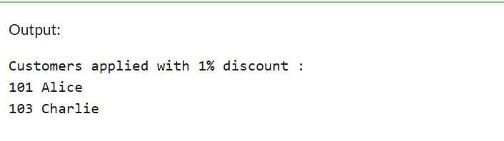

**SCENARIO 2**

BEGIN

DBMS_OUTPUT.PUT_LINE('Customers promoted to VIP status : ');

FOR rec IN (

SELECT customer_id, name

FROM customers

WHERE balance > 10000

) LOOP

UPDATE customers

SET is_vip = 'Y'

WHERE customer_id = rec.customer_id;

DBMS_OUTPUT.PUT_LINE(rec.customer_id ||' '|| rec.name);

END LOOP;

COMMIT;

END;

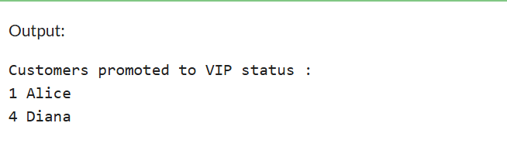

**SCENARIO 3**

BEGIN

DBMS_OUTPUT.PUT_LINE('Remainder for loan due within 30 days : ');

FOR rec IN (

SELECT c.name, l.due_date

FROM loans l

JOIN customers c ON l.customer_id = c.customer_id

WHERE l.due_date <= SYSDATE + 30

) LOOP

DBMS_OUTPUT.PUT_LINE(rec.name || ' ' || TO_CHAR(rec.due_date, 'DD-MON-YYYY'));

END LOOP;

END;

